SW Engineering CSC 648/848

Team 2

|  |  |
| --- | --- |
| Version History | Date |
| M2V1 | 20OCT2020 |



**Team**

Team lead/Scrum Master:

Jarett Koelmel; [jkoelmel1@mail.sfsu.edu](mailto:jkoelmel1@mail.sfsu.edu)

Front-end Lead: Chiu Wong

Front-end Dev: Michael Canson

Front-end Dev: Paul Borst

Back-end Lead: Brooke Porter

Back-end Engineer/Git Master: Eri Chen

SFSU | CSC648/848

Milestone 2 Documentation

Fall 2020

Table of Contents

1. Data Definitions V2 2

2. Functional Requirements V2 9

3. UI Mockup and Storyboards 15

4. High-Level Architecture & Database Organization 29

5. High-Level UML Diagrams 32

6. Key Risks 34

7. Project Management 35

# Data Definitions V2

**Unregistered Users**

An Unregistered User is a user that does not currently have an account or is not logged into the system. Their usage of the website is limited to the landing page which displays information about the application and company and the registration page so they can create an account if needed.

**Functionality**

* Can see general info on the landing page and access registration
* Cannot access therapist dashboard, listings of other therapists, exercise library, or any information about patients that is shared between other registered users

**Registered Users (Therapists & Administrators)**

A registered user is a user that has an active account and has had their credentials authenticated in order to be considered logged in. Users are largely physical therapists, with some administrative personnel mixed in. The capabilities of these two use cases overlap significantly. This table will provide all necessary

**Functionality**

* Can access therapist dashboard which provides instant insight to messages, current and potential client lists, and custom workout playlists for assignment
* Can access directory of other therapists for purposes of sharing information and patient-submitted videos, when permitted by patient
* Can access patient progress logs of patients directly associated to the user
* Can view messages generated by patients associated with their user account
* Cannot see metrics and statistics of other users, unless user has administrative permissions

**Attributes**

* User_ID(Primary Key): int
* Email: string
* Password: hashed-string
* Name: string
* Address (Composite): string
  + Handled via a separate table so references of many therapists in one office can be handled by one data entry, attributes broken into elements (house number, street, city, state, zip code, etc)
* Company: String
* Specialization: [Injury/Area]
  + This can be either specific injured areas (back, knee, shoulder) or specific area of expertise (sports injury, elderly rehabilitation, pediatrics, etc)
* Patients: [patient_id]
  + Used by the foreign key in the patient table to associate therapists to patients under their care. 1:M relationship
* Prospective Patients: [patient_id]
  + Also used by the foreign key in the patient table to associate with a chosen therapist prior to confirmation of service
* Admin(Foreign Key): recursive relationship
  + Will relate this user, when applicable, to the administrator that supervises the PT

**Administrator**

An administrator has a recursive relationship with the user table in that all of the functionality of the user is inherited but the additional functionality is discrete from traditional users. All of the attributes will be the same for the administrators as it is for the therapist users, with the key difference being that admins can check the tracking statistics and patient progress logs generate by all the PTs they supervise.

**Functionality**

* Can see the tracking statistics of all therapist accounts under their supervision
* Can run reports of therapist statistics over different time scales for performance assessments
* Can see patient progress reports of all patients associated to their therapists for purposes of quality control and client satisfaction
* Can remove therapist accounts

**Attributes**

* Admin_ID(Primary Key): int
* User_ID(Foreign Key): int

**Patient**

A patient is a user that has an account and is logged into the patient portal. While this is a discrete element from the application this team is building, their data is essential to the proper operation of our therapist portal.

**Functionality**

* Can directly message therapists currently assigned to patient
* Can view the directory of therapists in the system to assist in finding a suitable therapist that meets the patient’s needs for rehabilitation
* Can upload videos of home exercises performed for therapists to review and provide feedback on
* Can view feedback on videos uploaded to their therapists
* Can grant permission for their personal videos to be shared to other therapists/patients

**Attributes**

* Patient_ID(Primary key): int
* Name: string
* Address (Composite): string
  + Will be handled via a separate table so references of many therapists in one office can be handled by one data entry, attributes broken into elements (house number, street, city, state, zip code, etc)
* Injury: [Injury]
  + This can be used to filter therapists that provide services for their injuries or specific needs
* Therapist: int
  + This will be a foreign key to relate this data entry to the associated therapist
* Assignment: [Exercises]
  + This will be used to point to the exercise regimen created by their therapist
* Progress: [Log entry] (string)
  + Each progress entry from the therapist will be appended to this log entry array.

**Exercise Library**

The exercise library will contain all videos that can be utilized by therapists on the system. The ability to augment this collection of videos is afforded to the therapists via their video upload tools within the exercise library page. This will allow for crowd-sourcing of more specific exercises that are required beyond the initial offering by the application.

**Functionality**

* Can be searched based on the tagged body parts so that therapists can find specific exercises and videos faster
* Can be added to a workout playlist which can also be stored in a separate table that allows for quicker referencing of already constructed workouts
* Can be appended by therapist-uploaded videos for non-extant exercise videos

**Attributes**

* Exercise_ID(Primary Key): int
* Exercise_altText: string
* Length: int
* Description: string
* Tags: [string]
  + This array of tags will be to filter search results and return those applicable to the therapist

**Patient Video Library**

The patient video library will contain videos from all patients that have been uploaded to the system. The videos will be connected to their uploader and this will prevent other therapists from viewing them unless they are the associated therapist for that patient. The option to share videos does not immediately release them for viewing by anyone, but relies on therapists to share the videos at their discretion.

**Functionality**

* Can be shared at the individual level, as dictated by the uploader.
* Can only be accessed by proper users
* Cannot be searched for obvious privacy reasons

**Attributes**

* Video_ID(Primary Key): int
* Video_altText: string
* Length: int
* Description: string
* Feedback: string
  + Used to store therapist feedback tied directly to a patient’s video
* Shared: boolean
  + This will be decided at time of upload in the patient upload by a checkbox that will allow for their therapist to utilize their video beyond assessment purposes

**Custom Workout Library**

The custom workout library is primarily tied to each therapist as they create workouts for their patients to perform and assign them accordingly. The ability to share workouts previously made is key to simplifying therapist productivity system-wide.

**Functionality**

* Can contain references to numerous exercises and associated descriptions that detail to the patient what needs to be done, how often, and how many times (repetitions)
* Can be shared between therapists at their discretion
* Can be renamed as needed

**Attributes**

* Workout_ID(Primary Key): int
* Title: string
* Exercises: [Video_ID]
  + This array of Video_IDs will point the Workout to the correct exercise videos
* Descriptions: [String]
  + Array pairs with video IDs in order and lets the patient know what is to be done for each assigned exercise

**Messages**

The messages are a collection of encrypted messages that can only be seen and accessed by the patient/therapist pair involved in creating the communication. This direct message system will allow for asynchronous, around-the-clock, connections to be made between patients and therapists to suit their needs flexibly.

**Functionality**

* Can only be sent between patients and therapists associated with one another
* Exists on the system for the duration of the patient’s active status on the system, after which, can be deleted at the discretion of the therapist

**Attributes**

* Message_ID(Primary Key): int
* Message: hashed string
* Patient_ID: int
* Therapist_ID: int
  + Both therapist and Patient IDs are used for ensuring recipient and can be built into hashing algorithm so that the unique IDs accessing them affect encryption and ensure privacy

**Progress Log**

The progress log is a collection of inputs from the therapist that details a particular patient’s progress throughout their time in therapy. This provides a sortable history of rehabilitation process and is viewable by the therapist and any administrator assigned to that therapist.

**Functionality**

* Can be sorted by date and time of creation
* Can be appended to by therapist in charge of patient’s therapy
* Can be viewed by administrators in charge of therapist that created the entries

**Attributes**

* Log_ID(Primary Key): int
* Log: [Entry]
  + This is an array of entries that will be generated as the therapist creates them
* Patient_ID: int
* Therapist_ID: int

**Progress Entry**

A progress entry is the unit contained within the larger data structure, progress log, it will have pertinent information about the patient’s status and progress as detailed by the therapist at the time of creation.

**Functionality**

* Can be created and edited by therapist
* Can be viewed by administrator
* Contains patient information related to rehabilitation progress

**Attributes**

* Entry_ID(Primary Key): int
* Entry: string
* Created_on: date-time
* Log_ID: int

**PT Activity Log**

A Pt Activity Log will function via a table of entries, each of which is tied to the respective PT via a foreign key. Their will be a column that allows for activity logging which an enumeration of standard operations that are completed by a PT, like assigning workouts, responding to messages, providing patient feedback, and writing progress log entries.

**Functionality**

* Will be automatically generated via browser tracking
* Can be queried by PT to create reports on their activity
* Can be queried by admin to create reports on activity of any of their subordinates

**Attributes**

* Activity_ID(Primary Key): int
* Activity_Type: String
* Created_on: date-time
* Patient(Foreign Key): int

# Functional Requirements V2

**Priority 1 (Core Functionality):**

* **Unregistered Users**

FR1 – PT and Admin shall be able to create a profile containing all relevant personal details

* 1. Profile creation shall rely on organizational email domain, such that creation of multiple profiles for a single person cannot be easily achieved
* **Registered Users**

FR3 – PT able to view all current patient profiles

3.1 PT database entries shall contain an array of patient IDs they are currently providing care for

FR4 – PT able to view all prospective patient profiles

4.1 PT database entries shall also contain a separate array of patient IDs for those patients that desire to be seen by a specific therapist but have not been confirmed by the PT yet

FR5 – PT able to upload training videos into exercise library

5.1 PTs may require to augment the baseline training video data with very specific and custom exercises for their clientele.

5.2 PTs can upload their own videos as long as all required fields are filled out in the submission form so that our database’s informational integrity is not compromised

FR6 – PT able to delete uploaded videos by patients

6.1 This is based on the assumption that uploaded videos from the patient portal are stored in our database

6.2 The deletion of videos should be done automatically upon removal of a patient from the system

6.3 Deletion of individual videos after they are no longer useful to the PT is important for maintaining low overall database size

FR7 – PT able to pick training videos from the exercise library to create custom exercise plan

7.1 Curated exercise plans are integral to the efficacy of physical therapy, especially in a fully remote rehabilitation plan

7.2 Saving such exercises for re-use allows for quicker assignment to later patients and expedites the therapist’s workflow

FR8 – PT able to drag and drop exercises from library to new playlist

8.1 Allowing for drag and dropping of exercises to create playlists allows for an intuitive and interactive method of creation of workouts and should augment the user experience positively

FR9 – PT able to assign customized exercise plan to patient(s)

9.1 Assigning custom exercise plans is essential for therapists to provide adequate instruction and care for their clients

9.2 Management of multiple patients with similar injuries and needs will be faster through an ability to assign a new workout to many clients at one time

FR11 – PT able to view current exercise plan assigned to patient

11.1 Quick assessment of current exercise plans assigned will be accessible from the dashboard with minimal effort

FR16 – PT should be able to give feedback to patient’s videos via text

16.1 After viewing a video from a patient, PT shall be able to leave feedback directly on the video via a built-in comment section that will be visible to the patient

FR19 – Patient able to ask question via text communication

19.1 From the patient portal, text communication between patients and PTs shall be accessible only by proper therapists

19.2 Messages created shall be properly connected to patient and therapist IDs to ensure privacy

FR20 – PT able to respond to patients via text communication

20.1 PT should only see messages intended for their particular user ID

20.2 Message encryption shall be handled utilizing personal information between parties to assist in privacy concerns

FR23 – PT able to track progress of patients

23.1 PTs will generate a significant amount of data about the clients over time and will need to reference progress over weeks and month.

23.2 The list of progress log entries can be filtered or sorted by date and time

* **Admin**

FR2 – Admin shall be able to delete or modify PT user profiles

2.1 Admins can adjust PT user profiles to rectify issues and errors of those therapists that are under their supervision

* 1. Admins can delete PT user profiles in the event the therapist leaves the company/organization

**Priority 2 (Expanded Functionality):**

* + **Registered Users**

FR10 – PT can assign extant workout programs to new/different clients

10.1 While being able to assign newly created workout plans to clients is extremely important, being able to reuse workouts for clients with similar needs as those in the past will help therapists perform their job faster

FR12 – PT able to view patient video history

12.1 PT should be able to view the history of patient videos beyond those recently uploaded to provide a reference point easily for their progress log entries

FR17 – PT able to share videos of exercises with all other PTs

17.1 PT uploaded exercise videos will be automatically integrated into the database of accessible videos so that other PTs will be able to utilize them to build out an exercise program for their clients

FR18 – PT able to share videos of patient exercises with another PT

18.1 If allowed by the patient-uploader, a PT should be able to select the video for sharing and choose another PT from the directory listing of PTs in the network

FR21 – PT able to receive email notifications

21.1 PTs are often out of the office when patients need assistance, this notification system will fill that gap and tell PTs when new alerts in the system have been generated for them

FR22 – PT able to adjust frequency of emails

22.1 In an effort to improve the user experience, adjustable email frequency ensures that the therapist is not inundated with emails

22.1.1 The longer frequency options will allow for only the alerts generated since the last email went out to be shown

FR24 – PT able to see time indicator on patient profile

24.1 Showing an indication of time spent working on a specific patient’s profile will allow for quick assessment by both administrators and therapists as to how much time they have been dedicating to specific patients and whether they need to focus their attentions more broadly

24.2 As much of the functionality of patient interaction will be based around a single profile page, tracking of this information should be easily manageable

FR25 – PT able to generate a report on PT activity regarding patient interaction based on day, week, month, etc.

25.1 This report will show a list of current patients assigned to the PT running the report and breakdown interaction according to the desired time-scale

25.2 Granularity of reports will be dictated by user options and additional formatting and graph outputs may be considered in the future

FR27 – Text communication between patient and therapist shall be encrypted for confidentiality purposes

27.1 Building a hash around the involved parties’ information allows for more unique key generation and can easily encrypt messages between users such that they are only readable by the proper end-user

* **Admin**

FR25 – Admin able to generate reports on PTs under supervision regarding patient interaction based on day, week, month, etc.

25.1 The implementation of this functional requirement will be very similar to that of the PT, but with the added ability to generate reports across multiple PTs at the same time and output all data at once

FR26 – Admin able to remove patient user profile

26.1 Limiting access to admins for removal of patient profiles ensures this power is limited to only a handful of people and not readily accessible by therapists so accidental loss of information is not common

**Priority 3 (Optional/Desired Functionality):**

* **Registered Users**

FR13 – Pt should be able to draw lines directly on videos

13.1 Being able to draw lines directly on videos allows for faster assessment of patients and reference points for range of motion and overall mobility

FR14 – PT drawn lines should have their angles calculated automatically

14.1 Assessing patients through drawing on videos with automatic angle calculations provides a great benefit to therapists to assess patients faster

FR15 – PT should be able to estimate the pose of a client from the uploaded video

15.1 Utilizing open source AI tools, real-time pose estimation would allow for instant visualization of mobility and range of motion of a patient without interference from the therapist

# UI Mockup and Storyboards

A drop-down menu for the navigation between pages. User sign in as Physical Therapist. The PTs will see a dropdown menu displaying other options after login.

When you click the login button, it will bring you to the login prompt.

When you click the Register Now button, it will bring you to the sign-up page.

A Text field for PTs User to enter their Email Address and Password.

When PTs User has not registered to the portal, Click Sign Up hyper link will bring user to the register page.

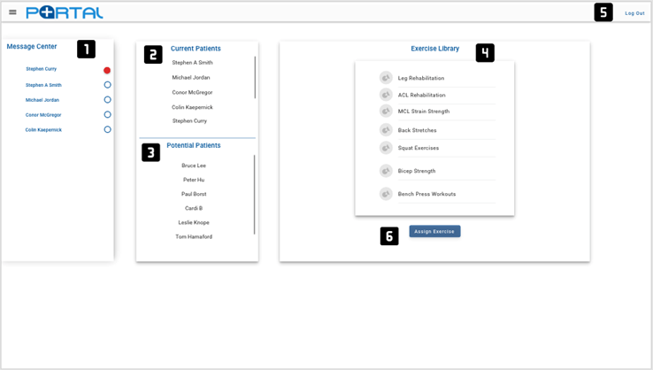Once PTs User enter email and password, Click Log In button to login to the portal.

A Message Center to display all the patient messages, the red light alerts the user to new message waiting.

A Display grid for the Current Patient’s List.

A Display grid for the Potential Patient’s List.

A Display for PTs to view all the exercise Library.

A Button for PTs to logout the PT Portal.

Assign Exercise Button is to create customized exercise.

A Message Center for Pt to read the communicate with the particular Patient.

A Text Field for Pt to reply message to the particular Patient.

A Send Button to send out the reply message.

A Drop-Down Menu for the PTs to edit their profile, exercise library, settings.

A Display Screen to show the current patient list.

Left top corner display a current patient’s profile.

An area for PTs to see Patients Upload videos.

This shows the assigned exercises for particular patient.

A Progress log will display current patient’s activities and PT thoughts about patient status throughout rehabilitation.

An Upload button for PT user to upload exercise for the library, for multiple select, PTs can use the select box.

A Delete button for PT User to delete exercise for patient.

PTs can select the video, enter playlist title and description in textbox in order to create a customized exercise plan.

Click Create Exercise button to create a customized exercise plan.

A Search bar for PTs to search for exercises in library.

Assign Button is to assign the exercise to particular patient or patients.

A Drop-down list for PTs to change the portal Setting, they can change Email frequency, email or password.

To change the Email Frequency, PTs can choose hourly, weekly and monthly. Hit the Save button to save the setting.

Place to change the Email Setting.

Place to change the Password Setting.

A Textbox field for PTs to create a PT User Account.

A Drag Down list for PTs to select Gender setting.

A Register Button for PTs to register their PT Account.

**User Stories**

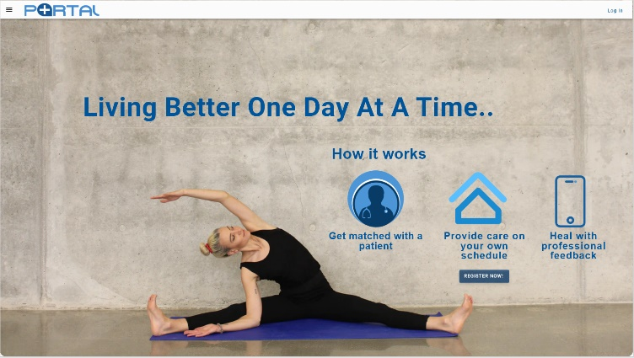**Signing Up/Initial Login– Lisa**

Today is Lisa’s first day as a PT at an office that utilizes the Netic Health portal and she has been asked to sign up and log into Portal in order to gain access to her dashboard. Lisa types the URL into the search bar and the landing page appears. The landing page has a woman demonstrating a stretch below the opening motto of “Living Better One Day at A Time.” Lisa glances across the page and notes that there is a “Register Now” button above the left foot of the woman. She clicks it.

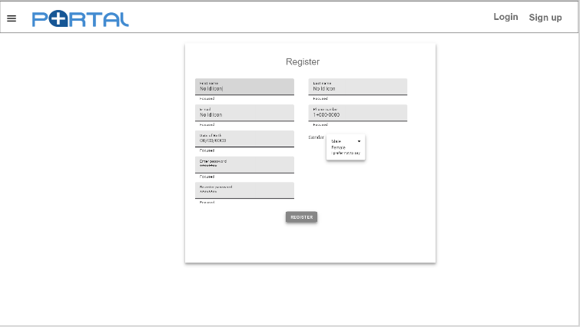The register page has appeared and Lisa sees a standard set of text boxes requesting some general information about her, including her phone and email. Lisa creates a new password as part of the process and clicks the “Register” button.

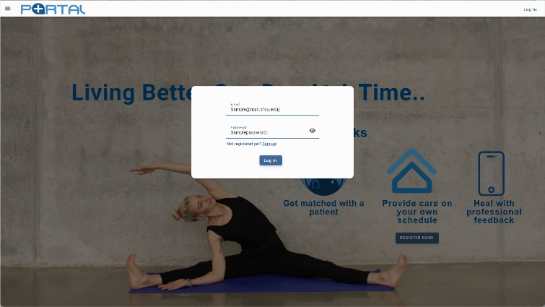

The landing page has returned, except this time a log in popup has appeared in the center and the page itself has slightly greyed indicating that it wants Lisa to enter her email and password. She does so and clicks the “Log In” button. The system recognizes her email and password. Lisa’s dashboard opens up. Mission accomplished. Lisa has signed up and logged into her dashboard.

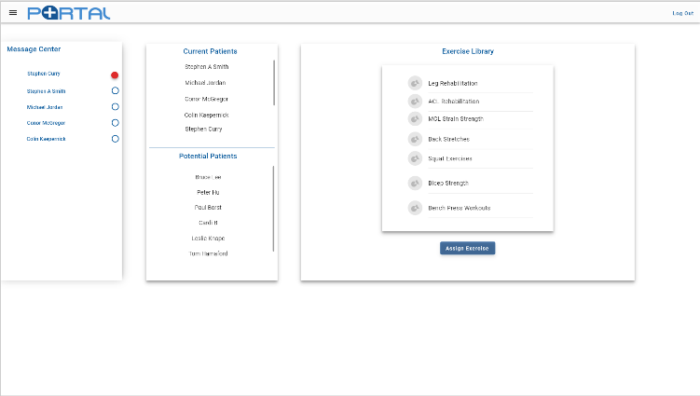**Reading & Answering Patient Messages - Alice**

Alice has been busy all-day assessing patients, both in person and via the portal, but before she leaves, she wants to check her messages. After logging in from the landing page, her dashboard opens up. In the box on the left-hand side labeled “Message Center” one of Alice’s patients has sent her a message. A bright red indicator shows that the message is new. Alice clicks on the name of the patient who sent the message.

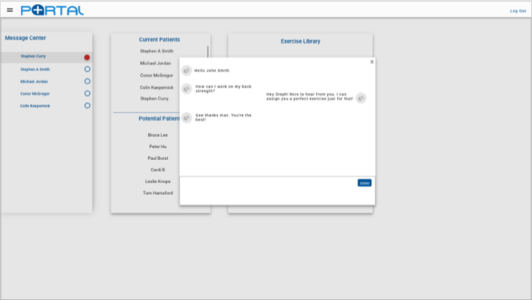The page greys and a scrolling chat box has appeared in the center. Looks like the patient is expressing a concern about strengthening their back. Alice knows the perfect exercise for that and indicates that she will add it to his routine. Alice clicks “Send” and is happy that she was able to continue her ongoing conversation with her patient so quickly and easily without navigating away from her dashboard.

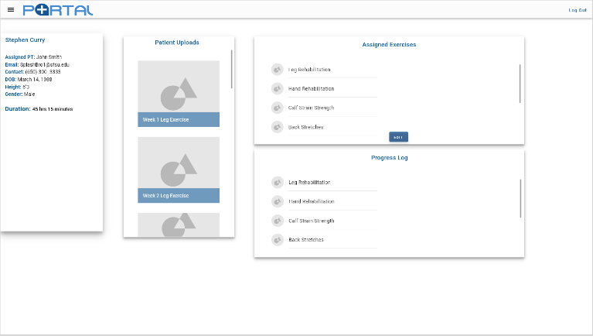

**Updating Patient Workout– Veronica**

Veronica’s current patients are listed on the center box of her dashboard, she clicks on the name of a patient she would like to review. The patient’s profile appears and provides a brief snapshot of the patient’s information and their current workout regimen. Veronica wants to update the patient’s assigned exercise routine. In the upper left-hand corner Veronica clicks on the triple bar icon where a menu drops down. She clicks on “Exercise Library”.

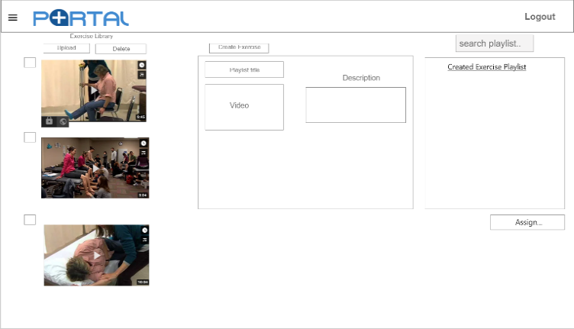Veronica using the select boxes next to the scrolling video library choses what videos she wants to put into the new routine. Next to each video she is able to type an additional instruction such as, four sets of ten in the description box. Once done Veronica clicks on “Create Exercise” and it is then listed in the playlist where she can not only assign it to this patient, but others as well when they reach this level. The re-usability of assigning a playlist to different patients saves Veronica’s valuable time freeing her up to serve a larger number of patients.

**GUI Designs**

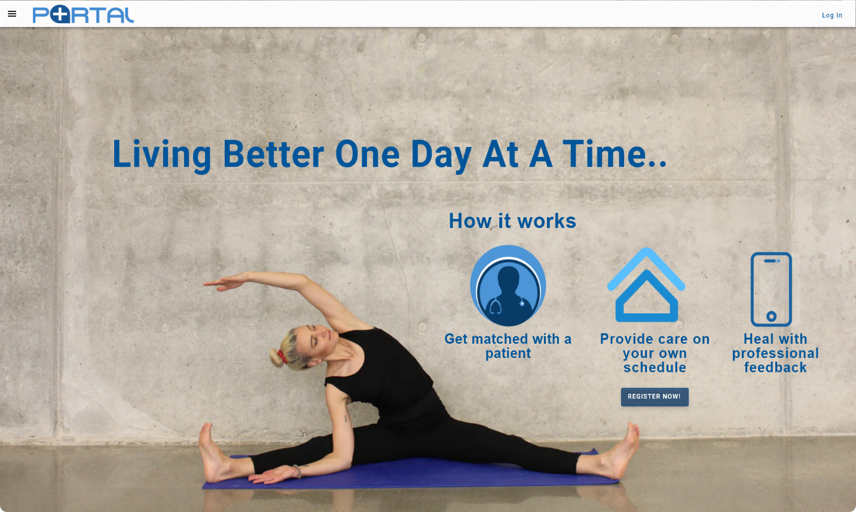**Landing Page**

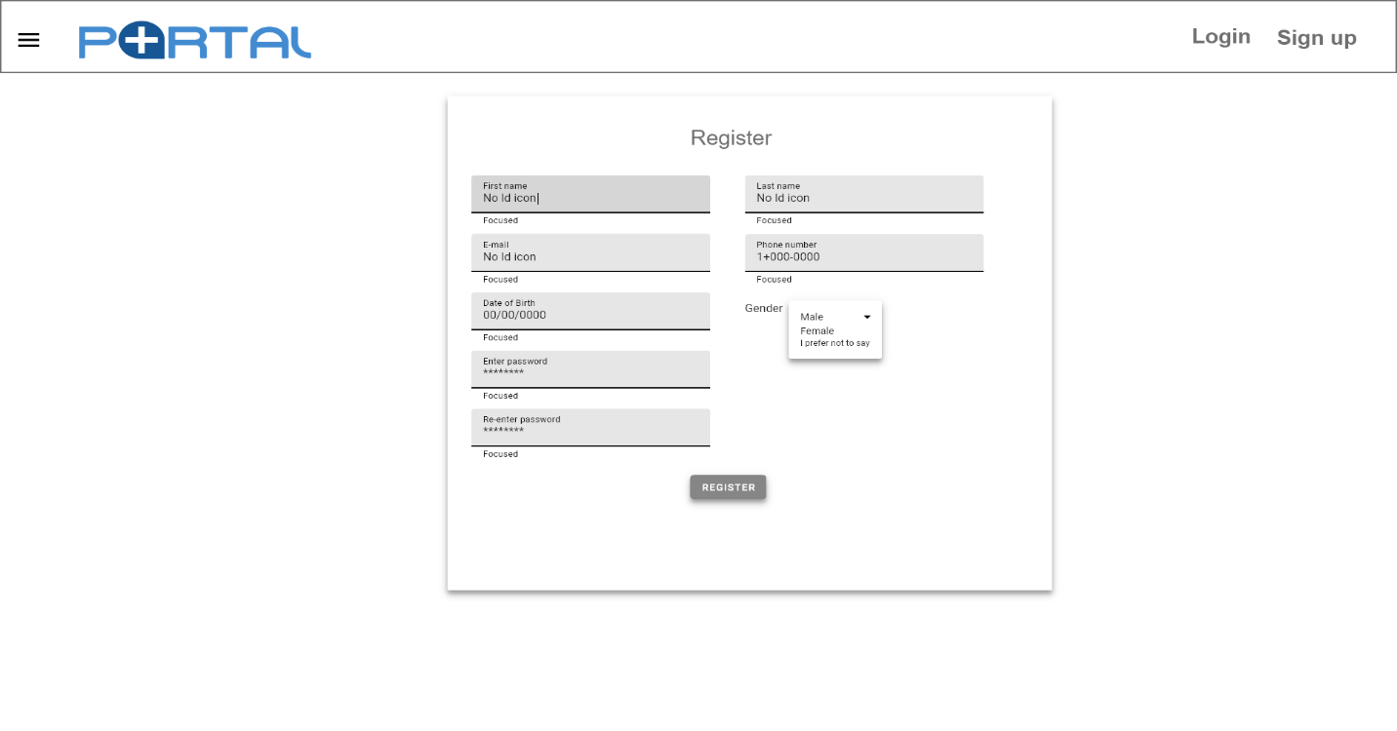**Registration**

**Login**

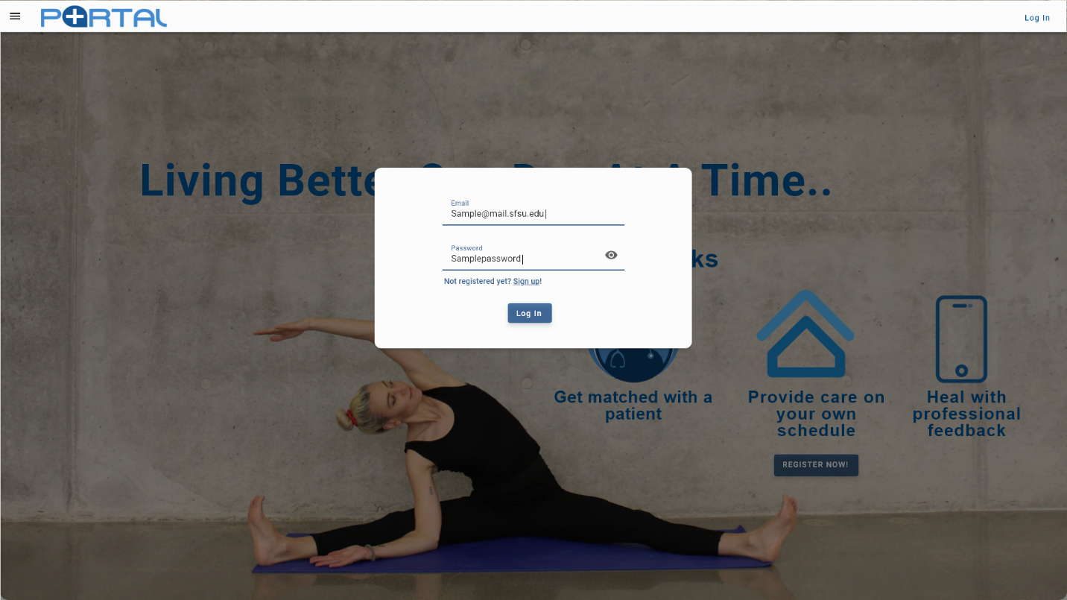

**Dashboard**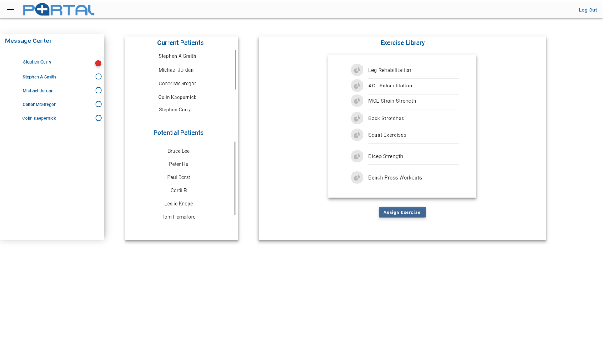

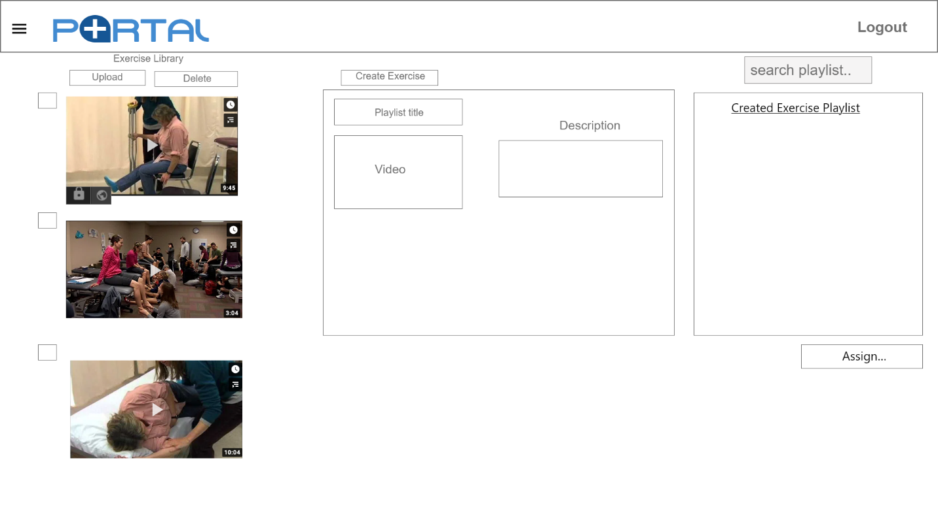**Exercise Library**

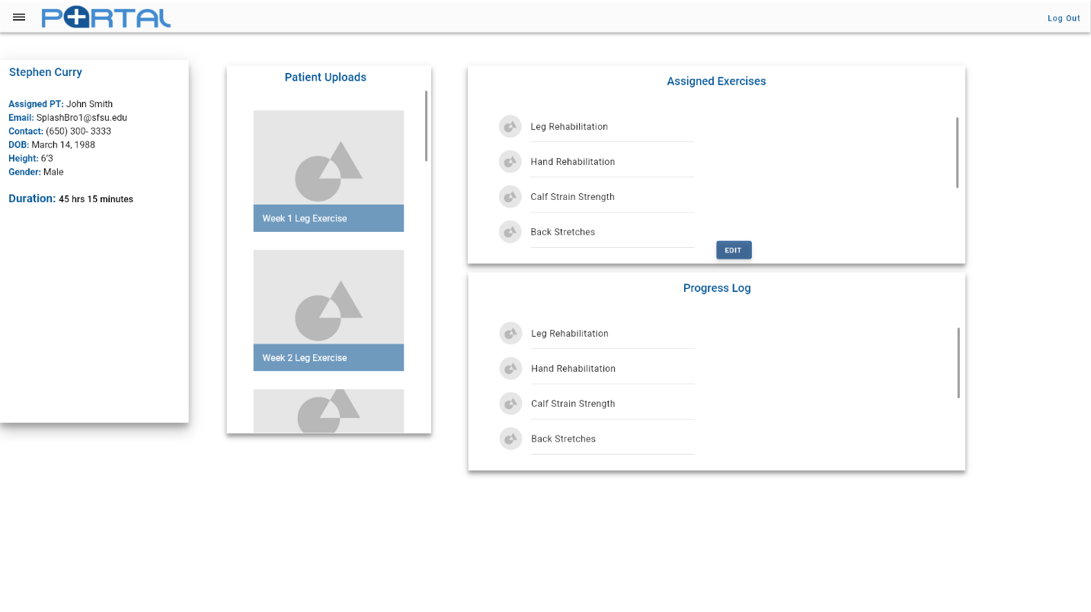**Patient Profile**

**Message Center**

# High-Level Architecture & Database Organization

**Database Organization**

Our database will be structured around 10 main entities that are all related to one another in various ways, currently these entities are:

* + Registered User
  + Administrator
  + Patient
  + Exercise
  + Custom Workout
  + Patient Video
  + Message
  + Progress Log
  + Progress Entry
  + PT Activity Log

Our database will be implemented via MySQL on AWS RDS. As a relational database, the relationships created will be extremely helpful in organizing data efficiently and compactly for faster CRUD operations. The baseline relationships are:

* + The Registered Users, in our case, physical therapists will treat 0 or many patients
  + A Registered User has a recursive relationship with Administrators, such that Registered Users can be Administrators and all Administrators are Registered Users
  + An Administrator manages 0 to many other Registered Users, physical therapists
  + A Patient has only one therapist (Registered User) at any given time
  + An Exercise can participate in 0 to many Custom Workouts
  + A Custom Workout can have 0 to many Exercises
  + A Patient can have 0 or 1 Custom Workouts currently assigned to them
  + A Patient can upload 0 to many Patient Videos
  + A Patient Video can have only one Patient
  + A message can have only one creator (Registered User, patient or therapist)
  + A message can only one recipient (Registered User, patient or therapist)
  + A Progress Log can have 0 to many Entries
  + An Entry can belong to only one Progress Log
  + A PT Activity Log an have only one PT

Because the scope of this project is limited to only the physical therapist dashboard/portal, the patient data will be synthesized beforehand to simulate a live working environment.

**Scaling considerations**

As the database relies heavily on exercise videos and patient videos all of which are stored within this database and hosted/streamed exclusively from it, an actual enterprise implementation of this application would have to consider significant hosting and storage overhead. An implementation of max file size for video uploads can be set, at the client’s request, in our application to handle this issue on the front end, but the overall requirements will scale exponentially as the user-base grows and patients have longer histories within the system. Patient record maintenance will have to comply with HIPAA regulations.

Utilizing Apache Spark, implemented in Java on the backend, will allow for horizontal scaling across a distributed database cluster network while still maintaining a faster operating time than an implementation of Hadoop MapReduce. This provides the client greater flexibility in scaling options that suit their financials needs as the userbase grows.

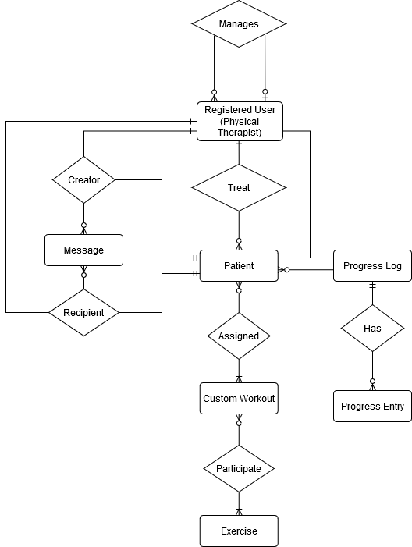Entity Relationship Diagram (See UML Diagram for expanded information):

# High-Level UML Diagrams

1. UML Class Diagram

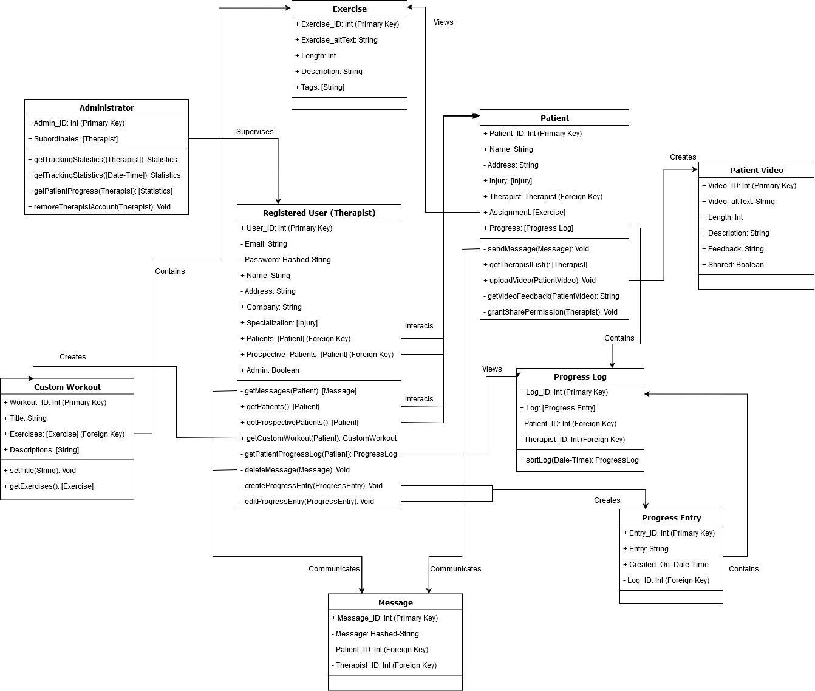

1. UML Deployment Diagram

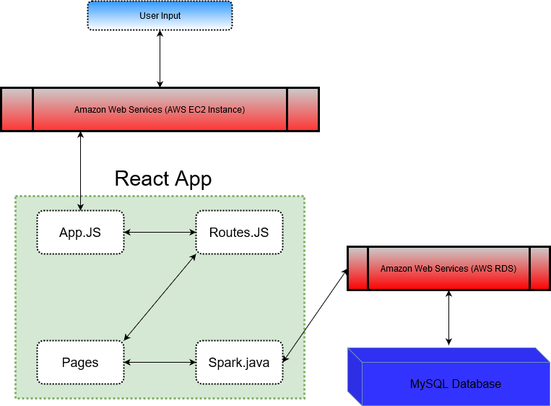

# Key Risks

The following is a risk assessment of the development team in its current status:

1. **Skills**

Our team has a diverse set of skills that cover most of the requirements to fully develop this project. However, it seems that the skills are largely segmented between individuals and the minimal overlap may result in issues with workload balancing in the future as development progresses and becomes more intensive. In order to rectify this, it would benefit the team to cross-train or study with individuals that have skills they do not possess, if time and schedules permit.

1. **Schedule**

As a fully remote team, our scheduling cannot revolve around on-campus time for large development meetings or sessions. Coupling this with the extant work schedules of our teammates, the limited times available to have full-team meetings forces the team to rely more heavily on asynchronous communications, which is not preferable as we enter later stages of development and time-sensitive milestones. This presents a significant risk currently, but one our team is seeking to remedy before it becomes more disruptive. The best approach our team is currently undertaking is to break out into smaller teams to work on specific areas when people are available to meet, this has helped facilitate development outside of regularly scheduled meetings.

1. **Technical**

The current technical challenges revolve around adapting open-source AI tools to operate efficiently without our current frameworks and software stack. The most challenging aspects for development of the final product involve the optional but highly-desired functional requirements that facilitate faster assessment of patient-uploaded videos. The AI component presents a large computational requirement that may directly affect the end-user experience if not implemented correctly. This is certainly the largest technical risk currently facing the team.

1. **Teamwork**

The current environment which does not allow for direct interpersonal collaboration presents a significant risk to the team. This is exacerbated by the fact that the entire team is made up of people that have never worked together before, nor met in person. Bridging this gap, our team attempts to utilize Zoom, Slack, and GitHub to its full potential to maintain open lines of communication and meet all objectives in a timely and organized fashion. However, this is not to say that risks are not present when looking forward into further development.

# Project Management

Current development surrounding milestone 2 has relied on initiative undertaken by frontend and backend team leads to delegate tasks that fall within their scope to team members and flesh out granular details. As smaller deadlines and modules are completed, requirements and technical details are compared between the two teams for incongruency and issues are rectified during team meetings to reassess the team’s direction and path moving forward so that the team is moving towards the milestone goals as a cohesive unit.

Looking forward to future tasks and development, adhering to a flexible and adaptive strategy that is inherent with agile software engineering will allow for our team to pivot as necessary to meet changing demands from our client and address technical hurdles as they present themselves. Addressing the issues and errors that are bound to happen will be handled via introspective post-mortems so that the team can use these moments to learn and better themselves as engineers and prevent the weaponization of errors in development to embarrass or deride other team members which is notoriously bad for morale and teamwork.